***SYNOPSIS***

***Report on***

***AI Quizify***

***by***

*SHAGUN (2300290140167)*

*SAKSHI GUPTA (2300290140154)*

*SARTHAK GUPTA (2300290140159)*

*SHIVANSH DUBEY(2300290140175)*

***Session:2023-2024 (III Semester)***

*Under the supervision of*

***Dr. VIPIN KUMAR***

### *KIET Group of Institutions, Delhi-NCR, Ghaziabad*

**

### *Department Of Computer Applications*

***KIET GROUP OF INSTITUTIONS, DELHI-NCR,GHAZIABAD-201206****( 2024-25)*

***ABSTRACT***

*The AI-Based Quiz using MERN Technology and Tailwind CSS is a dynamic web application designed to provide an adaptive and personalized quiz-taking experience.*

*This platform allows multiple users to log in, select quizzes by subject .The platform uses AI to generate quiz questions, making the quizzes unique for each user*

* ***How It Works***
* ***User Login/Sign-Up****: Users start by creating an account or logging in to the website.*
* ***Language Selection****: After logging in, users choose the language they want their quizzes in.*
* ***AI-Generated Questions****: The platform uses AI to generate quiz questions based on the chosen language, providing new questions each time.*
* ***Score Tracking****: As users complete quizzes, their scores are saved on their profiles.*
* ***Leaderboard and Dashboard****: Users can view their own scores and also see the top scorers on the leaderboard, encouraging competition.*
* ***Technology-Used*** *AI Quizify is built using the* ***MERN*** *stack:*
* ***MongoDB****: For storing user data and scores.*
* ***Express.js*** *and* ***Node.js****: For managing the backend and handling requests.*
* ***React.js****: For creating the interactive user interface.*
* ***Tailwind CSS****: For making the design responsive and easy to use on any device.*
* ***Conclusion****AI Quizify is a simple, user-friendly quiz platform that uses AI to create*

*personalized quizzes for each user. It tracks scores, making learning fun*

*and competitive with a leaderboard that highlights top performers****.***

***TABLE OF CONTENTS***

*Page Number*

1. *Introduction --*
2. *Literature Review --*
3. *Project / Research Objective --*
4. *Project Flow/ Research Methodology --*
5. *Project / Research Outcome --*
6. *Proposed Time Duration --*
7. *References/ Bibliography --*

***Introduction***

*Name : - AI Quizify*

*AI Quizify is a web platform where users can sign up or log in to take quizzes. After logging in, users can choose a subject for their quiz, and the platform adjusts the difficulty of the questions as they take the quiz, making it personalized and more fun.*

*AI Quizify is built using the* ***MERN stack*** *(MongoDB, Express.js, React.js, and Node.js). This means it runs smoothly and connects the user interface with the backend to ensure everything works well, including storing quiz data, managing user logins, and generating quizzes.*

*The design of the platform is created using* ***Tailwind CSS****, which makes sure that the website looks good and works properly on any device, whether it’s a phone, tablet, or computer. The website automatically adjusts to different screen sizes for a better user experience.*

*Each user has a dashboard where they can see their quiz scores and track how they are improving over time. There is also a leaderboard that shows the top scorers, which encourages users to do their best and compete with others.*

*The goal of AI Quizify is to make taking quizzes more fun, engaging, and customized for each user, using AI to improve learning.*

***Literature Review***

* ***Artificial Intelligence in Learning****: AI is becoming more popular in education technology, making learning more personalized and adaptable. Machine learning algorithms can look at how users respond to quiz questions and how much time they take, allowing the system to adjust question difficulty in real-time. These adaptive systems provide a better learning experience by matching questions to users' skill levels.*
* ***Importance of Active Learning****: Quizzes are essential for active learning, encouraging users to engage with the material rather than just passively read. By answering questions, learners actively recall information, which improves memory retention and understanding. This hands-on approach boosts confidence and helps users succeed in their studies.*
* ***Feedback in Learning****: Providing immediate feedback after each quiz question helps users understand what they got right or wrong. This feedback can guide them in their learning process, allowing them to focus on areas where they need improvement. Quick feedback keeps them motivated to continue taking quizzes and improving their skills.*
* ***MERN Stack for Web Development And Tailwind CSS*** *: The MERN stack is a popular choice for creating dynamic web applications. It allows developers to use JavaScript for both the front-end and the back-end , resulting in fast and scalable applications. MongoDB is great for storing large amounts of data, like quiz questions and user information, while React.js offers an interactive and quick user interface. Node.js and Express.js handle server operations and manage user requests effectively.**Tailwind CSS for Responsive**Design Tailwind CSS is a utility-first framework that enables developers to build custom and responsive designs quickly*

***Project/Research Objectives***

* ***Primary Objectives:***
* ***User Authentication and Multi-User Login****:*
  + *Implement a secure login system using Node.js and Express.js, allowing multiple users to create accounts, log in, and access quizzes based on their preferred subjects.*
  + *Use JWT (JSON Web Token) for secure session management, ensuring that user data remains private and protected.*
* ***AI-Powered Adaptive Quiz System****:*
  + *Use AI to evaluate user responses in real-time and adjust the difficulty of quiz questions. This adaptive feature will ensure that users are constantly challenged, preventing quizzes from being too easy or too difficult.*
  + *The AI will track user performance and analyze trends over time to improve question selection and offer tailored quiz experiences.*
* ***Subject-Specific Quizzes****:*
  + *Provide users with the ability to choose quizzes based on their preferred subject areas. These subject-specific quizzes will be pulled from a database, with questions categorized by difficulty and topic.*
  + *The system will ensure that each quiz is dynamically generated, offering a different set of questions each time a user takes the test.*
* ***Score Dashboard****:*
  + *Create a dashboard where users can view their quiz results, including scores, accuracy, and improvement over time. The dashboard will also display a comparison of performance across different subjects.*
  + *Provide visual analytics such as graphs and charts to help users track their progress and identify areas for improvement.*
* ***Secondary Objectives:***
* ***Admin Panel for Quiz Management****:*
  + *Develop an admin panel where administrators can add, edit, and delete quiz questions. Admins will also be able to categorize questions by difficulty and subject to ensure a broad range of topics and skill levels are covered.*
  + *Admins can review overall user performance and monitor which subjects or topics are most challenging for users.*
* ***Scalability and Performance****:*
  + *Ensure that the application can handle multiple users simultaneously without compromising on speed or performance.*
  + *Optimize the database structure to efficiently manage large volumes of quiz questions and user data.*

***Project/ Research Outcome***

### *Exploration of AI in Education:*

### Demonstrated the potential of AI (GPT) to generate customized and dynamic quiz content, showing the role AI can play in enhancing learning tools.

### *User Engagement with AI:*

### *Analysis of how users interact with AI-generated content, providing insights into user preferences and engagement patterns in AI-driven educational platforms.*

### *Using AI on a Large Scale:*

### *We explored how well GPT (an AI model) can handle many users at the same time, and whether it can create quizzes quickly for everyone.*

### *EInstant Feedback:*

### *We looked at how giving students quiz results right away can help them learn faster and stay motivated.*

### *Using AI with Web Tools:*

### *We successfully combined AI with popular web technologies (showing how AI can be part of modern websites and apps.*

### Project Flow

***AI Quizify***

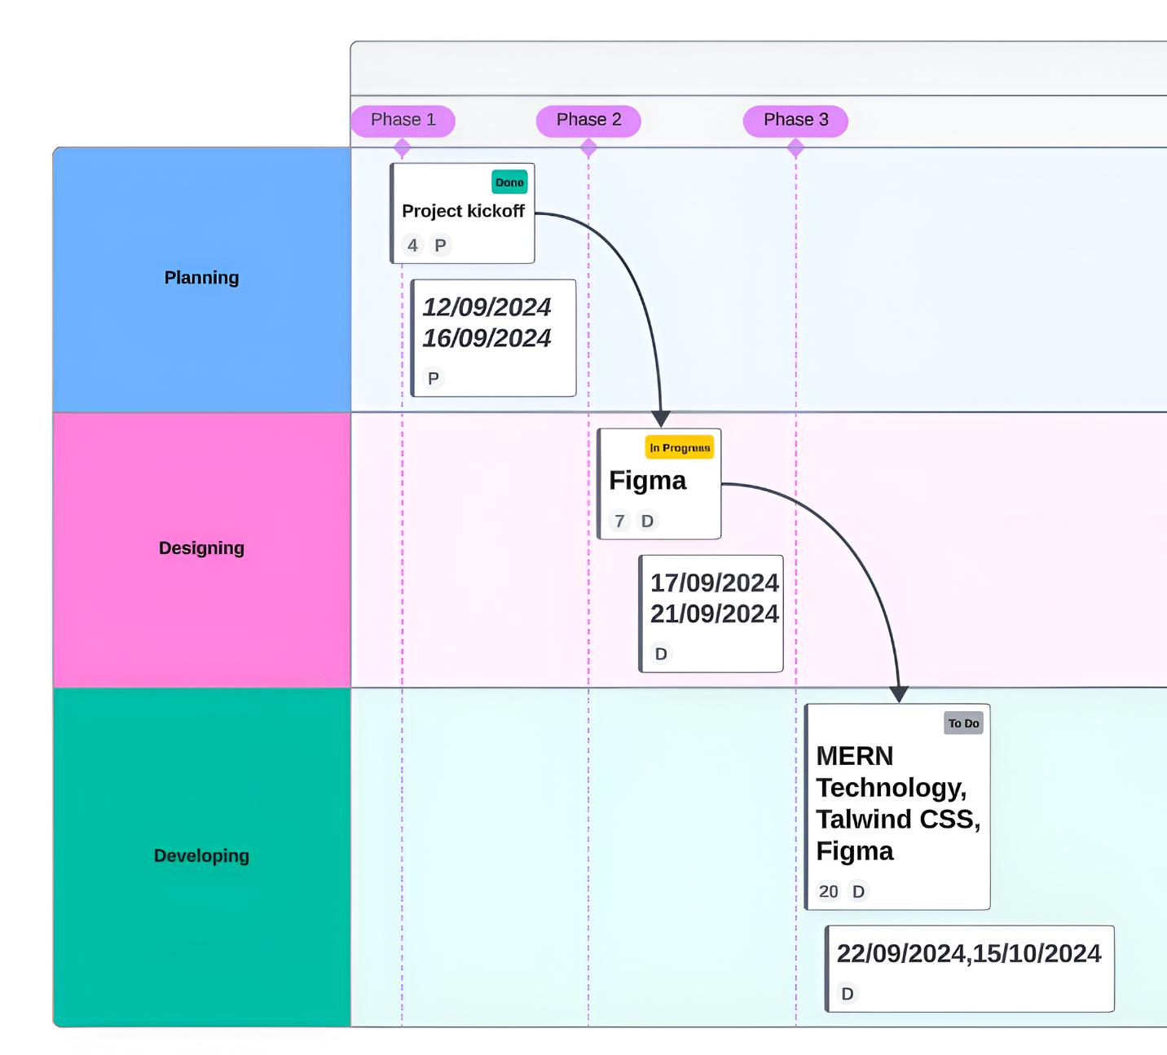

### Website *Figma Design Preview*

### *Landing Page*

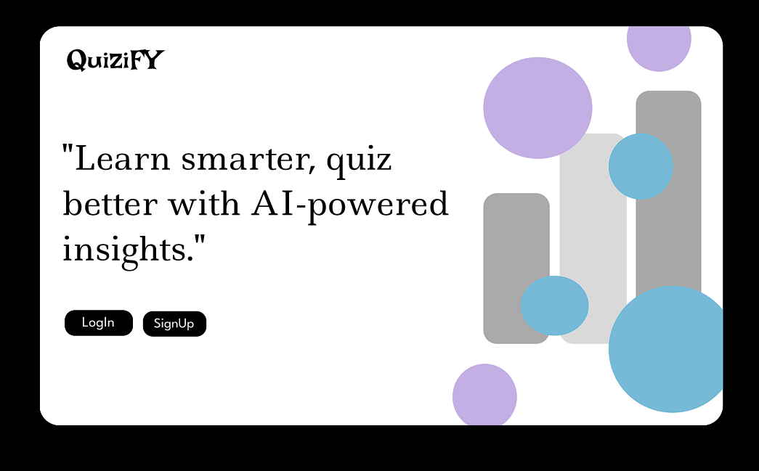

### *Log in Page*

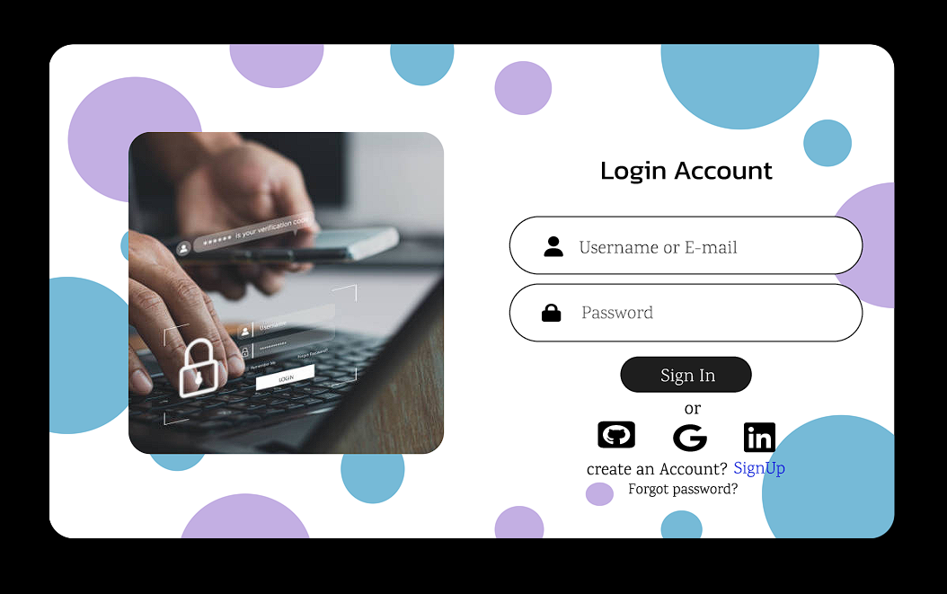

### *Sign Up Page*

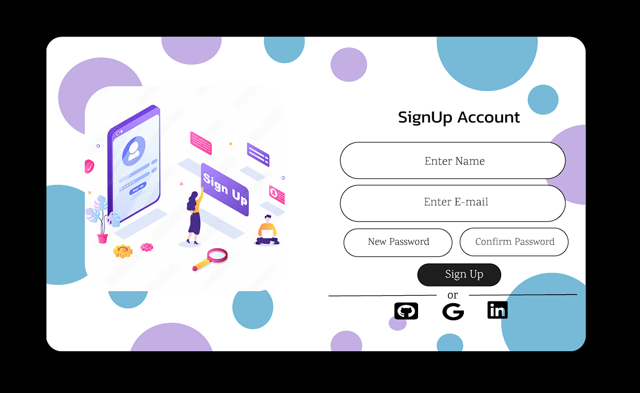

### *Dashboard*

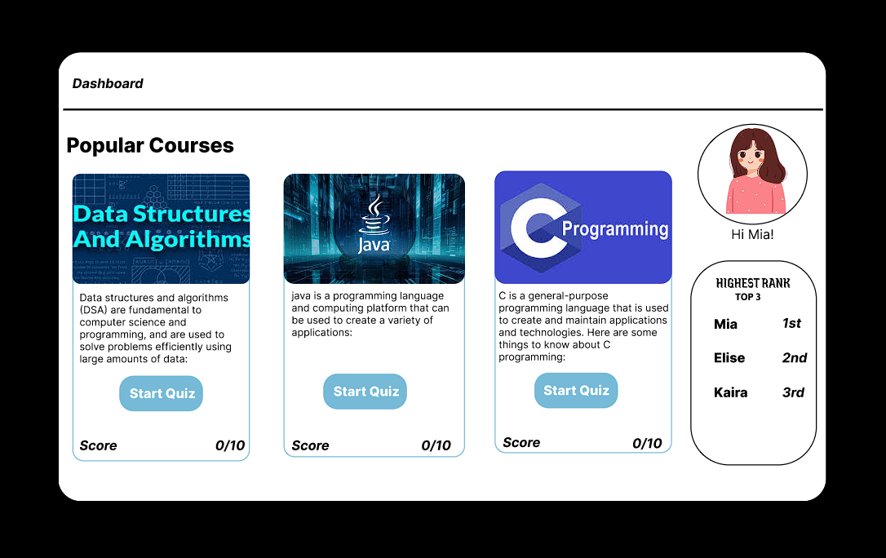

### *Quiz Page*

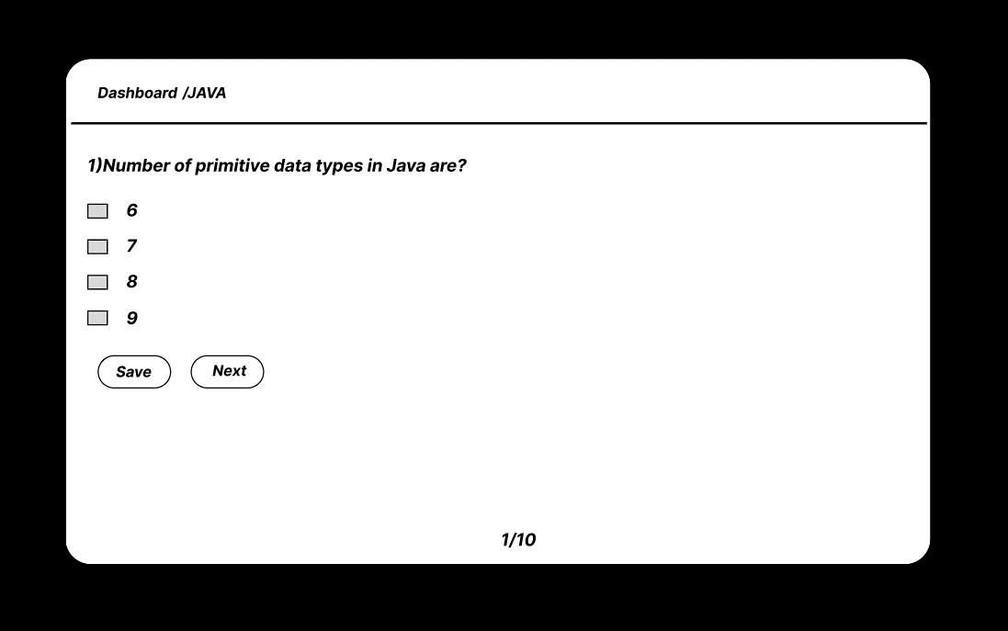

***DFD***

*+-----------------+*

*| User |*

*+-----------------+*

*|*

*| User Input*

*v*

*+-----------------------------+*

*| Receive User Input |*

*+-----------------------------+*

*|*

*| Formatted Request*

*v*

*+-----------------------------+*

*| Process Input |*

*+-----------------------------+*

*|*

*| API Request*

*v*

*+---------------------------- -----------+*

*| Send Request to ChatGPT API|*

*+---------------------------------------+*

*|*

*| ChatGPT Response*

*v*

*+------------------------------------+*

*| Receive and Process API |*

*| Response |*

*+-----------------------------------+*

*|*

*| Processed Response*

*v*

*+-------------------------------------+*

*| Generate Quiz Response |*

*+-------------------------------------+*

*|*

*| Quiz Response*

*v*

*+-----------------+*

*| User |*

*+-----------------+*